|  |  |
| --- | --- |
| *Pacific Gas and Electric Company* | |
| Release 9.7.5B Installation Guide | |
|  |  |
|  |  |
| Project | ED AM/GIS |
|  |  |
| Prepared by | Subhankar Baidya |
| Date | 9/29/2015 |
| Version | 1.0 |
| Version Type | Draft |

|  |  |  |  |
| --- | --- | --- | --- |
| Revision History | | | |
| Document # | Date | Author | Summary of Changes |
| 1.0 | 9/29/2015 | Subhankar Baidya | Initial Document Creation |
|  |  |  |  |

# Introduction

## Purpose

This document is intended to detail the implementation and configuration steps required to implement Release 9.7.5B Installation Guide. This document describes the various configuration aspects required to complete any manual or automatic patch associated with this release. Each section in this document contains the steps required to patch the system in production.

## Terms Used

|  |  |
| --- | --- |
| OOTB | Out of the box. Unmodified from the commercial version. |
| TFS | Team Foundation Server |

## External Documents

Referenced are any external configuration documents or exports. These are documents that contain more detailed information about configuring a system or documents that can be loaded into an application to perform the configuration detailed in this document.

1. Supporting documentation folder
   1. **TFS documentation location:**

$/EDAMGIS/Source_Development_10_2_1/Documentation/Data Model/Release Documentation/EDER/9.7.5B

## List of Fixes

Below is the list of change requests detailing all fixes for the data model for this release:

|  |  |
| --- | --- |
| **Item Number** | **Title** |
| [24676](http://edappgistfsprd1:8080/tfs/ElectricDistCollection/EDAMGIS/_workitems/edit/24676) | Master TFS DM 9.7.5B |
| [24678](http://edappgistfsprd1:8080/tfs/ElectricDistCollection/EDAMGIS/_workitems/edit/24678) | 50 scale polygon |
| [24677](http://edappgistfsprd1:8080/tfs/ElectricDistCollection/EDAMGIS/_workitems/edit/24677) | Class model names for 50 and 100 scale annos |
|  |  |
|  |  |

Contents

1 Introduction 3

1.1 Purpose 3

1.2 Terms Used 3

1.3 External Documents 3

1.4 List of Fixes 4

2 EDGIS 6

2.1 24678:50 scale polygon 6

2.2 24677: Class model names for 50 and 100 scale annos 9

2.3 Update Data Model Version Table 14

3 Known Issues 15

# EDGIS

## 24678:50 scale polygon

1. Copy **50ScaleBoundary.zip** from the shared location and paste it into a local folder and unzip.
2. Open ArcCatalog and connect the folder.

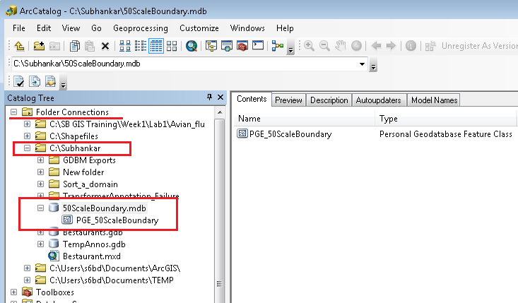

1. Open ArcCatalog database connection with **EDGIS** user.
2. Drag and drop PGE_50ScaleBoundary polygon feature class from 50ScaleBoundary.mdb to the **root node** of the database connection.

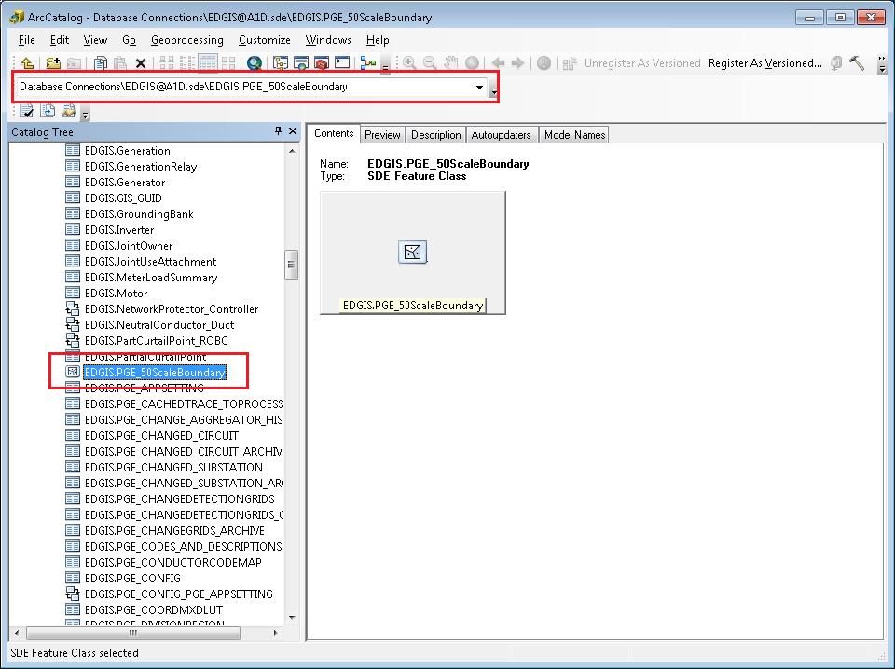

1. **Rename it to EDGIS.PGE_50SCALE_BOUNDARY**
2. Right click on the newly created feature class in EDGIS. Select Manage🡪Privileges…
3. Provide the privileges as shown below:

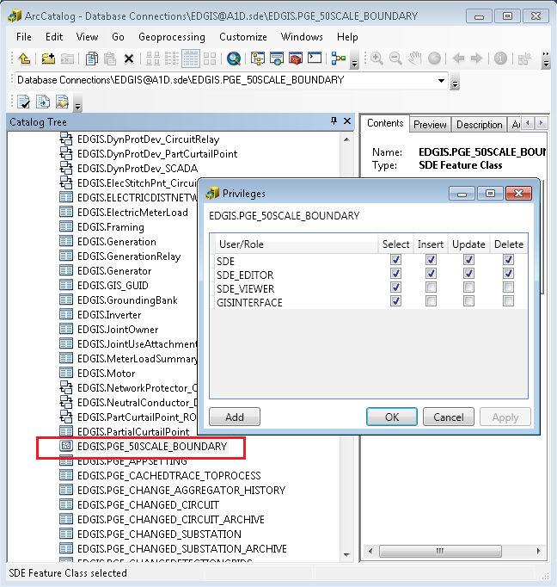

## 24677: Class model names for 50 and 100 scale annos

1. Connect to database with EDGIS user. Get exclusive access.
2. Add below two code-descriptions in PGE ED Object Class Model Name domain.

**Code** **Description**

PGE_50SCALEANNO PGE_50SCALEANNO

PGE_100SCALEANNO PGE_100SCALEANNO

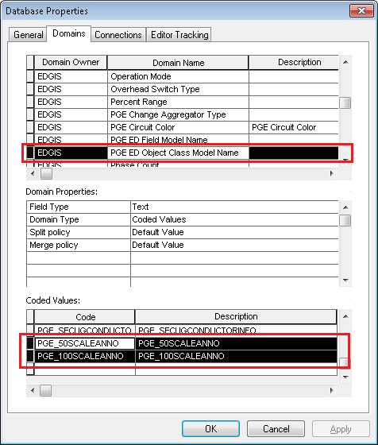

1. Click Apply. Click OK.
2. Navigate to EDGIS.ElectricDataset🡪EDGIS.**CapacitorBank50Anno**. Right click on it. Select “ArcFM Properties Manager”.
3. Go to Model Names tab. Assign PGE_50SCALEANNO from “PGE ED Object Class Model Name”.

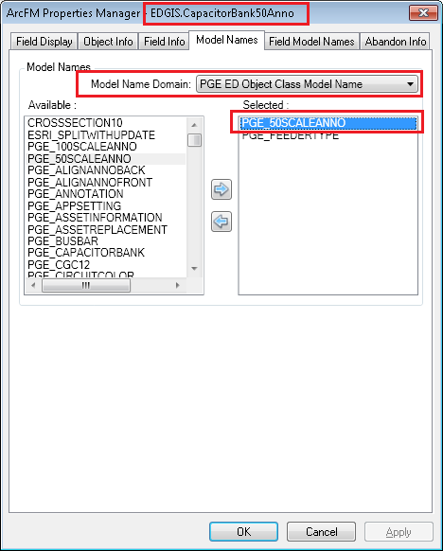

1. Click Apply. Click OK.
2. Assign PGE_50SCALEANNO for all the anno features classes as listed below:

**50 scale annotation feature classes**

* 1. CapacitorBank50Anno
  2. ConduitSystem50Anno
  3. CustAgreeNumber50Anno
  4. DCConductor50Anno
  5. DCDevice50Anno
  6. DcRectifier50Anno
  7. DeactivatedElecLineSeg50Anno
  8. DeliveryPoint50Anno
  9. DeviceGroup50Anno
  10. DistBusBar50Anno
  11. DynProtDevice50Anno
  12. FaultIndicator50Anno
  13. Fuse50Anno
  14. JobNumber50Anno
  15. NetworkProtector50Anno
  16. NeutralConductor50Anno
  17. PrimaryGeneration50Anno
  18. PriOHConductor50Anno
  19. PriUGConductor50Anno
  20. SecOHConductor50Anno
  21. SecondaryGeneration50Anno
  22. SecUGConductor50Anno
  23. StepDown50Anno
  24. StreetLight50Anno
  25. Substation50Anno
  26. SubsurfaceStructure50Anno
  27. SupportStructure50Anno
  28. Switch50Anno
  29. Transformer50Anno
  30. VaultPoly50Anno
  31. VoltageRegulator50Anno

Do **NOT** assign PGE_50SCALEANNO to EDGIS.CrossSection50Anno and EDGIS.ULSPriUGConductor50Anno.

1. Navigate to EDGIS.ElectricDataset🡪EDGIS.**CapacitorBankAnno**. Right click on it. Select “ArcFM Properties Manager”.
2. Go to Model Names tab. Assign PGE_100SCALEANNO from “PGE ED Object Class Model Name”.

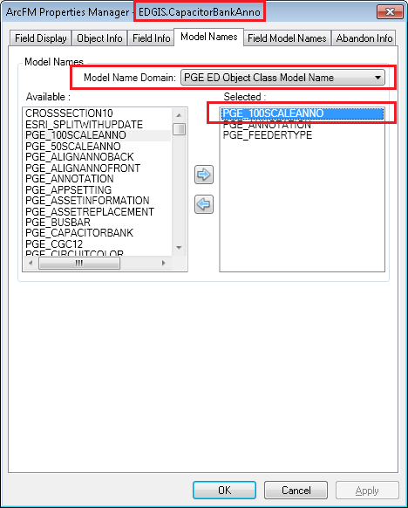

1. Click Apply. Click OK.
2. Assign PGE_100SCALEANNO for all the anno features classes as listed below:

**100 scale annotation feature classes**

1. CapacitorBankAnno
2. ConduitSystemAnno
3. CustAgreeNumberAnno
4. DCDeviceAnno
5. DcRectifierAnno
6. DeactivatedElecLineSegAnno
7. DeliveryPointAnno
8. DeviceGroupAnno
9. DynamicProtectiveDeviceAnno
10. FaultIndicatorAnno
11. FuseAnno
12. JobNumberAnno
13. NetworkProtectorAnno
14. NeutralConductorAnno
15. PrimaryGenerationAnno
16. PriOHConductorAnno
17. PriUGConductorAnno
18. SecOHConductorAnno
19. SecondaryGenerationAnno
20. SecUGConductorAnno
21. StepDownAnno
22. StreetLightAnno
23. SubstationAnno
24. SubsurfaceStructureAnno
25. SupportStructureAnno
26. SwitchAnno
27. TransformerAnno
28. VoltageRegulatorAnno

Do **NOT** assign PGE_100SCALEANNO to EDGIS.CrossSectionAnno and EDGIS.ULSPriUGConductorAnno.

## Update Data Model Version Table

**Database Configuration:**

1. Open SQL Plus.
2. Log in using the same server and user as was used in section 2.1.  
     
   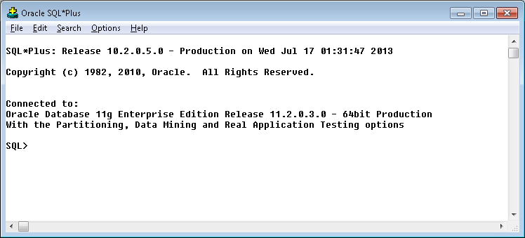
3. Run the SQL below:

update pgedatamodelversion set currentidc='N' where currentidc='Y';

insert into pgedatamodelversion (OBJECTID, CURRENTIDC, DATEAPPLIED, APPLIEDBYPERSONNAME, MODELVERSION) values (**SDE.VERSION_USER_DDL.NEXT_ROW_ID('EDGIS',(select registration_id from sde.table_registry where table_name='PGEDATAMODELVERSION'))**,'Y',sysdate,'***<your_name>***','**9.7.5B** GOLD');

commit;

# Known Issues

<Please List any other issues encountered here while following the document>